BIOL-10 HW5 (10 points max)

Name___________________________________

Due Tues, Oct 2nd, 2018
Questions cover Ch 3 and Ch 4 up to Forms of Dominance

MULTIPLE CHOICE. Choose the one alternative that best completes the statement
or answers the question.

1. Genes come in different versions called:
a) alleles.
b) loci.
c) genotypes.
d) chromosomes.
e) genomes.

2. Which of the following statements is TRUE?
a) The genotype is the physical appearance of a trait.
b) Alleles, genes, and loci are different names for the same thing.
c) The phenotype of a dominant allele is never seen in the F1 progeny of a monohybrid cross.
d) A testcross can be used to determine whether an individual is homozygous or heterozygous for a dominant allele.

3. What important genetics concept is being shown in the diagram?

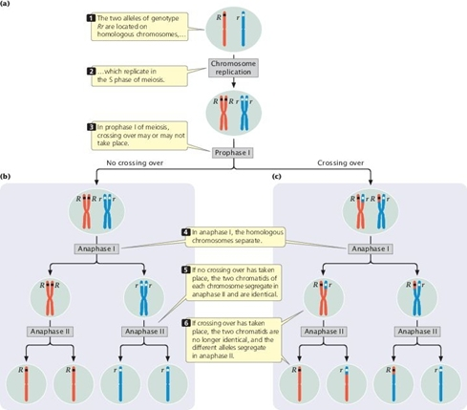
a) Mendel's principle of independent assortment
b) Mendel's principle of segregation
c) The molecular nature of alleles
d) The chi-square goodness-of-fit test
e) The results of a dihybrid cross

4. A phenotypically normal man has phenotypically normal parents but he has a sister who has cystic fibrosis caused by a recessive mutant allele. What is the probability that the man is heterozygous for the cystic fibrosis allele? (Hint- this is conditional probability)
a) 1/4
b) 1/2
c) 3/4
d) 2/3
e) 1/3

5. If two heterozygous Aa plants are crossed with each other, what will be the genotypic ratio found in the offspring?
a) 1:1
b) 3:1
c) 1:1:1:1
d) 2:1
e) 1:2:1

6. Two gene loci, A and B, assort independently, and alleles A and B are dominant over alleles a and b. What is the probability of producing an AB gamete from an AaBb individual?
a) 1/4
b) 1/2
c) 1/16
d) 9/16
e) 1 (100%)

7. Two parents are phenotypically normal, but one of their four biological children has a typical autosomal recessive trait. The other three children are phenotypically normal. It is very likely that:
a) the affected child is a girl.
b) the affected child is a boy.
c) the trait was expressed by one of the grandparents of the children.
d) the parents are both heterozygous for the trait.
e) if the affected child eventually marries a phenotypically normal spouse, all of their children will have the trait.

8. In pedigree analysis, consanguinity refers to:
a) mating between two heterozygous carrier parents.
b) the realization that phenotypes between children and grandparents are often more closely related than between children and parents.
c) mating between two closely related parents.
d) a situation where the children of two parents are adopted.
e) a situation where only one individual in the entire pedigree is affected with the trait or disorder.

9. Which of the following is NOT a typical characteristic of human traits that follow an autosomal recessive inheritance pattern?
a) They often “skip” generations.
b) They appear equally in males and females.
c) Parents of affected children are often phenotypically normal themselves.
d) When affected individuals marry phenotypically normal individuals, their children are often phenotypically normal.
e) All of the above are characteristic of autosomal recessive inheritance.

10. Most pedigrees showing a hypothetical human trait show the following characteristics:
• Males and females are equally affected.
• Two unaffected parents can have an affected child.
• In families in which the parents are unaffected but the children are affected, one-fourth of the children are affected.
What is the MOST likely mode of inheritance for this disorder?
a) autosomal recessive
b) autosomal dominant
c) sex-linked recessive
d) sex-linked dominant
e) determined by 4 loci

11. The ability to roll the tongue is caused by a dominant allele. A woman is a “roller,” but one of her parents is not. What is the woman's genotype?
a) homozygous dominant
b) heterozygous
c) homozygous recessive
d) either homozygous recessive or homozygous dominant
e) It cannot be determined from this information.

12. If the pedigree below is for an autosomal recessive characteristic, which individuals are definitely heterozygous?

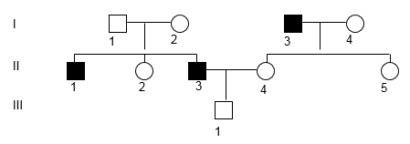
a) I-1, I-2, II-2, II-4, II-5
b) I-1, I-2, I-4, III-1
c) I-1, I-2, II-4, II-5, III-1
d) II-2, II-4, II-5, II-3
e) II-2, II-4, II-5, III-1

13. If the characteristic followed in the pedigree is autosomal recessive, what is III-1's genotype?

a) either homozygous dominant or heterozygous
b) definitely heterozygous
c) definitely homozygous dominant
d) must be homozygous recessive
e) homozygous dominant since he is a male but a female would be heterozygous

15. Betty has normal vision, but her mother is color blind. Bill is color blind. If Bill and Betty marry and have a child together, what is the probability that the child will be color blind?
The solution to this probelm is in your text on page 83. Show your work

16. What is the role of the SRY gene in humans?
a) It initiates the X inactivation process in females.
b) It is located on the X chromosome and causes the X to pair with the Y chromosome during male meiosis.
c) It is located on the Y chromosome and initiates the developmental pathway toward the male phenotype.
d) It is located on an autosomal chromosome and represses expression of autosomal genes in order to balance their expression level with genes on the X chromosome.
e) None of the answers is correct.

17. In a germ-line cell from a human male that is dividing, when do the X and Y chromosomes segregate?
a) during mitosis
b) during meiosis I, anaphase
c) during meiosis II, anaphase
d) They do not segregate; gametes contain a copy of X and a copy of Y.
e) just before meiosis begins

18. In humans, occasionally a baby is found that has the XX chromosomal karyotype but is phenotypically male. Which of the following statements might be a CORRECT explanation for at least some of these unusual cases?
a) A mutation has occurred in the SRY gene making it inactive.
b) An extra pierce of autosomal chromosome 15 is probably present in the genome but is too small to be detected.
c) A small piece of autosomal chromosome 15 is missing but is too small to be detected.
d) A piece of chromosomal material containing an active SRY gene is found attached to one of the X chromosomes.
e) The ratio of number of X chromosomes to number of sets of chromosomes is incorrect.

19. Red–green color blindness is X-linked recessive. A woman with normal color vision has a father who is color blind. The woman has a child with a man with normal color vision. Which phenotype is NOT expected?
a) a color-blind female
b) a color-blind male
c) a noncolor-blind female
d) a noncolor-blind male
e) a color-blind male or a color-blind female

20. If a female Drosophila that is heterozygous for a recessive X-linked mutation is crossed to a wild-type male, what proportion of female progeny will have the mutant phenotype?
a) 100%
b) 0%
c) 33%
d) 25%
e) 50%

21. A woman is phenotypically normal but her father had the sex-linked recessive condition of red-green color blindness. If she marries a man with normal vision, what is the probability that their two children will both have normal vision?
a) 4/9
b) 1/16
c) 9/16
d) 3/8
e) 3/4

22. What is the apparent purpose for X inactivation in humans and other mammals?
a) It allows for the levels of expression of genes on the X chromosome to be similar in males and females.
b) It allows for the levels of expression of genes on the autosomes to be similar to the levels of genes on the X chromosome.
c) It suppresses the expression of genes on the Y chromosome in males.
d) It reduces the amount of nondisjunction during meiosis in females.
e) It enhances the level of pairing between the two X chromosomes during meiosis in females.

23. The R locus determines flower color in a new plant species. Plants that are genotype RR have red flowers, and plants that are rr have white flowers. However, Rr plants have pink flowers. What type of inheritance does this demonstrate for flower color in these plants?
a) complete dominance
b) incomplete dominance
c) codominance
d) complementation
e) lethal alleles

24. Interactions among the human ABO blood group alleles involve _____ and _____.
a) codominance; complete dominance
b) codominance; incomplete dominance
c) complete dominance; incomplete dominance
d) epistasis; complementation
e) continuous variation; environmental variation

25. Crossing two yellow mice results in 2/3 yellow offspring and 1/3 nonyellow offspring. What percentage of offspring would you expect to be nonyellow if you crossed two nonyellow mice?
a) 25%
b) 33%
c) 66%
d) 75%
e) 100%

